# Edge Computing Lab

## Class: TY-AIEC

### School of Computing, MIT Art Design Technology University

#### Academic Year: 2024-25

**Experiment No. 7**

## Introduction

**Study of Classification learning block using a NN Classifier on Edge Devices**

**Objective:** Build a project to detect the keywords using built-in sensor on Nano BLE Sense / Mobile Phone

**Tasks:**

* Generate the dataset for keyword
* Configure BLE Sense / Mobile for Edge Impulse
* Building and Training a Model

## Study of Confusion matrix

## Introduction

Edge Impulse is a development platform for machine learning on edge devices, targeted at developers who want to create intelligent device solutions. The "classification block" equivalent in Edge Impulse would typically involve creating a simple machine learning model that can run on an edge device, like classifying sensor data or recognizing a basic pattern.

## Materials Required

* Nano BLE Sense Board

## Theory

GPIO (General Purpose Input/Output) pins on the Raspberry Pi are used for interfacing with other electronic components. BCM numbering refers to the pin numbers in the Broadcom SOC channel, which is a more consistent way to refer to the GPIO pins across different versions of the

Here’s a high-level overview of steps you'd follow to create a "Hello World" project on Edge Impulse:

**Steps to Configure the Edge Impulse:**

1. Create an Account and New Project:

* Sign up for an Edge Impulse account.
* Create a new project from the dashboard.

1. Connect a Device:

* You can use a supported development board or your smartphone as a sensor device.
* Follow the instructions to connect your device to your Edge Impulse project.

1. Collect Data:

* Use the Edge Impulse mobile app or the Web interface to collect data from the onboard sensors.
* For a "Hello World" project, you could collect accelerometer data, for instance.

1. Create an Impulse:

* Go to the 'Create impulse' page.
* Add a processing block (e.g., time-series data) and a learning block (e.g., classification).
* Save the impulse, which defines the machine learning pipeline.

1. Design a Neural Network:

* Navigate to the 'NN Classifier' under the 'Learning blocks'.
* Design a simple neural network. Edge Impulse provides a default architecture that works well for most basic tasks.

1. Train the Model:

* Click on the 'Start training' button to train your machine learning model with the collected data.

1. Test the Model:

* Once the model is trained, you can test its performance with new data in the 'Model Testing' tab.

1. Deploy the Model:

* Go to the 'Deployment' tab.
* Select the deployment method that suits your edge device (e.g., Arduino library, WebAssembly, container, etc.).
* Follow the instructions to deploy the model to your device.

1. Run Inference:

* With the model deployed, run inference on the edge device to see it classifying data in real-time.

1. Monitor:

* You can monitor the performance of your device through the Edge Impulse studio.

Paste your Edge Impulse project’s Results:

1. Dataset Image

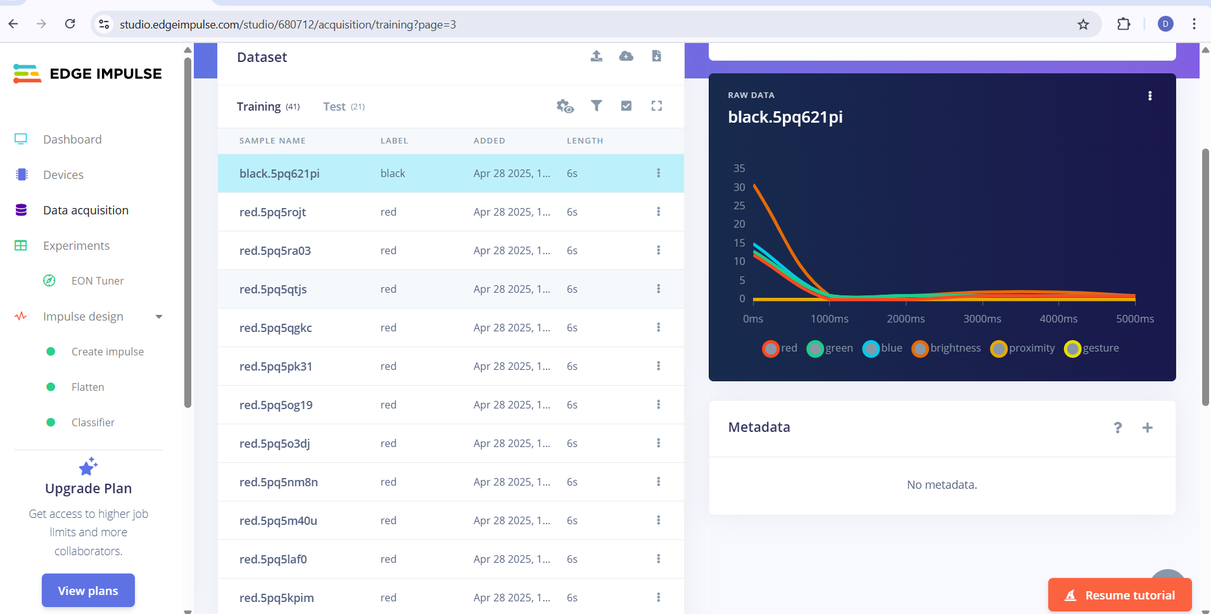

1. Feature extraction - Image

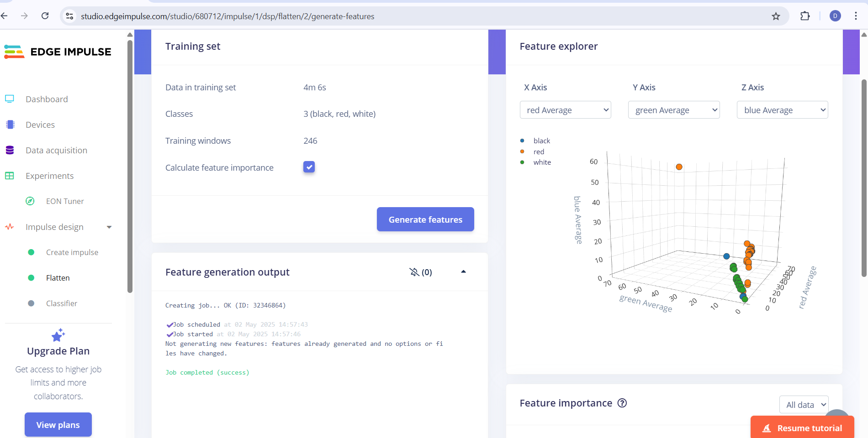

1. Accuracy / Loss - Confusion Matrix – image

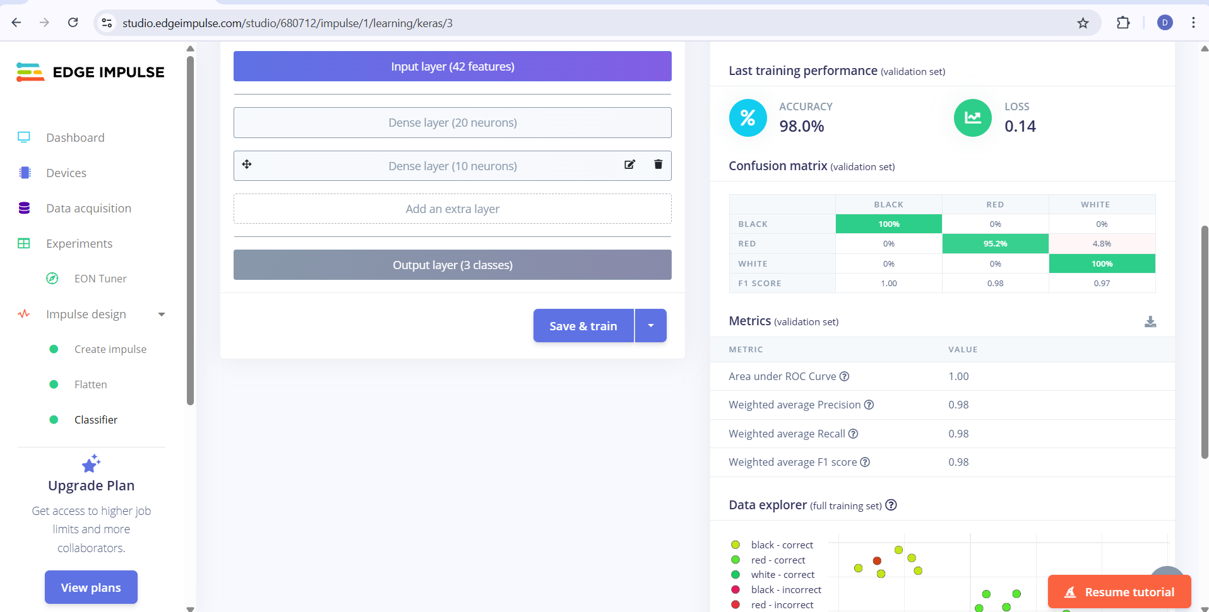

1. Validation Result – Image

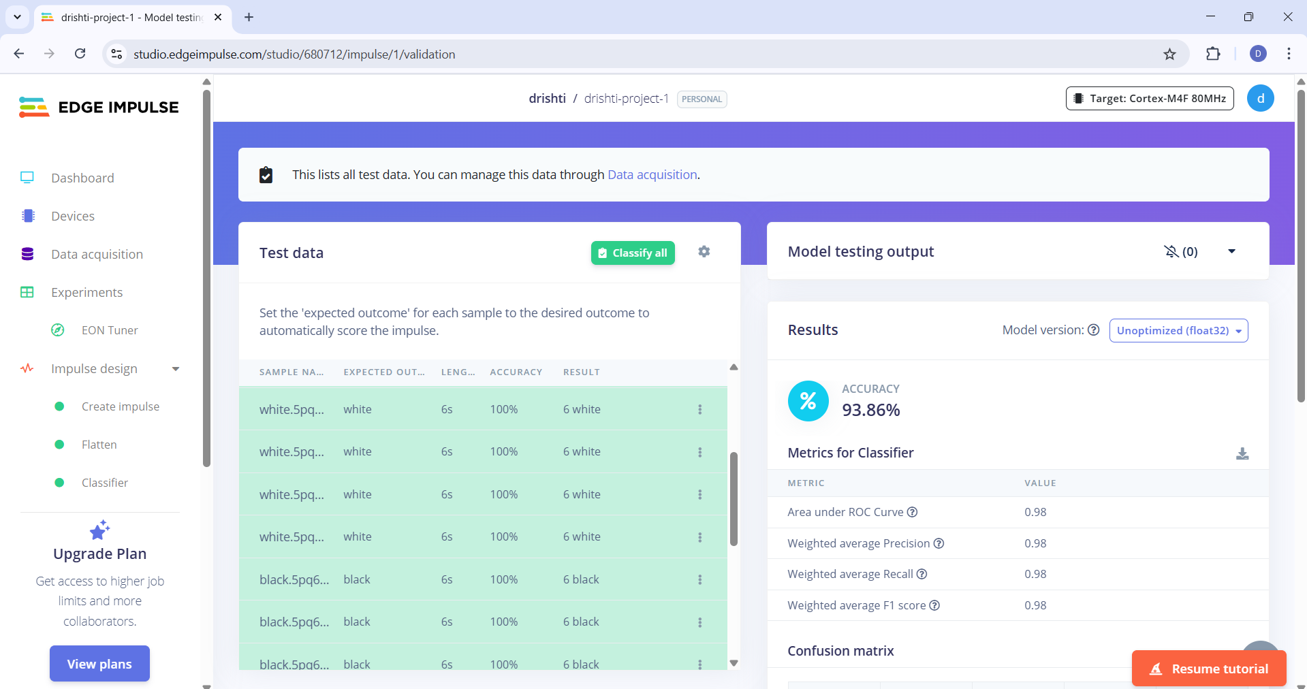

1. Copy the code of Arduino Sketch

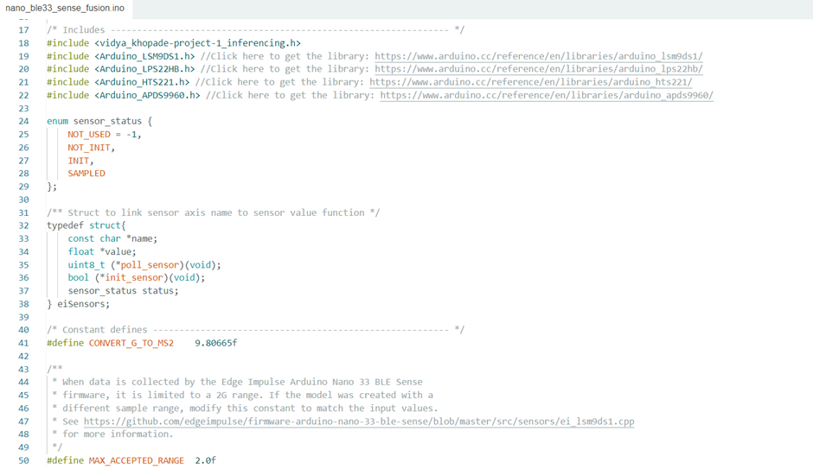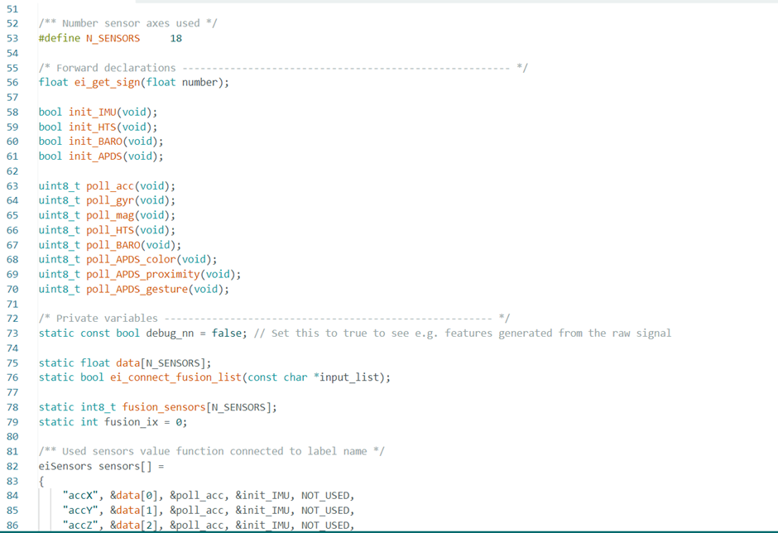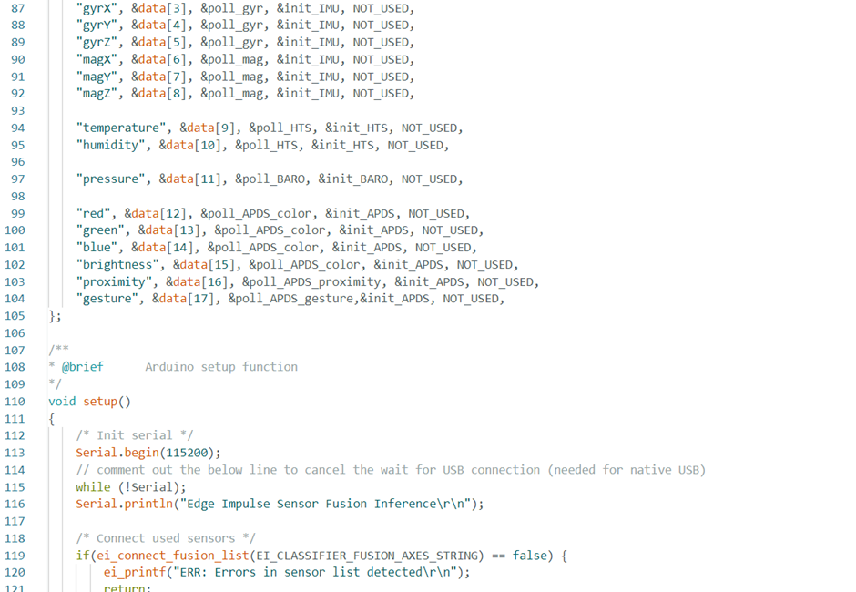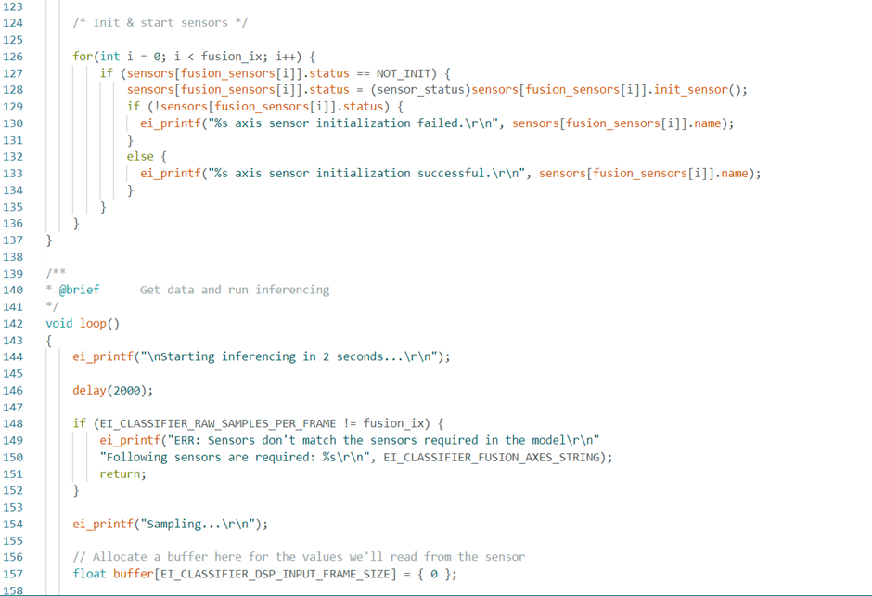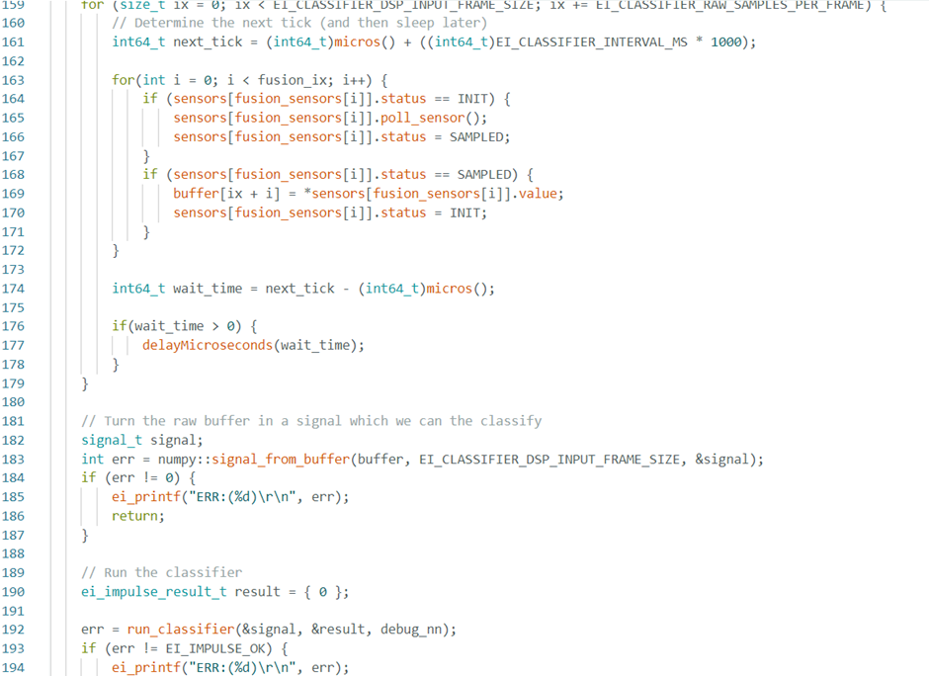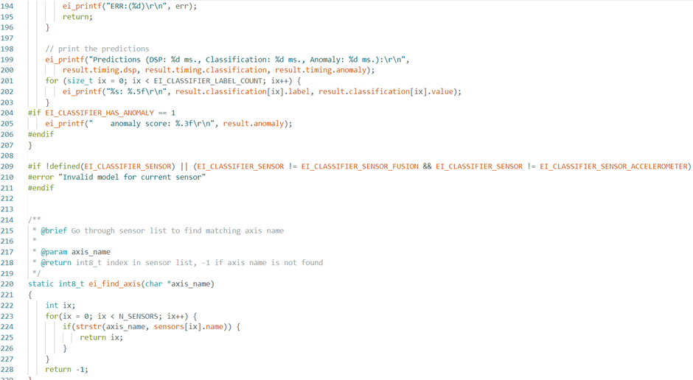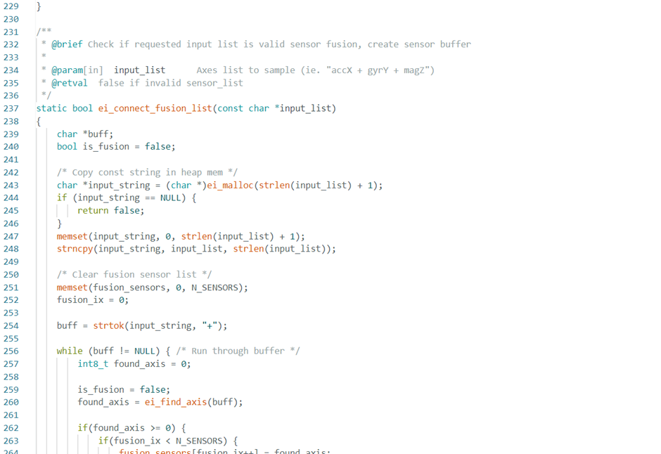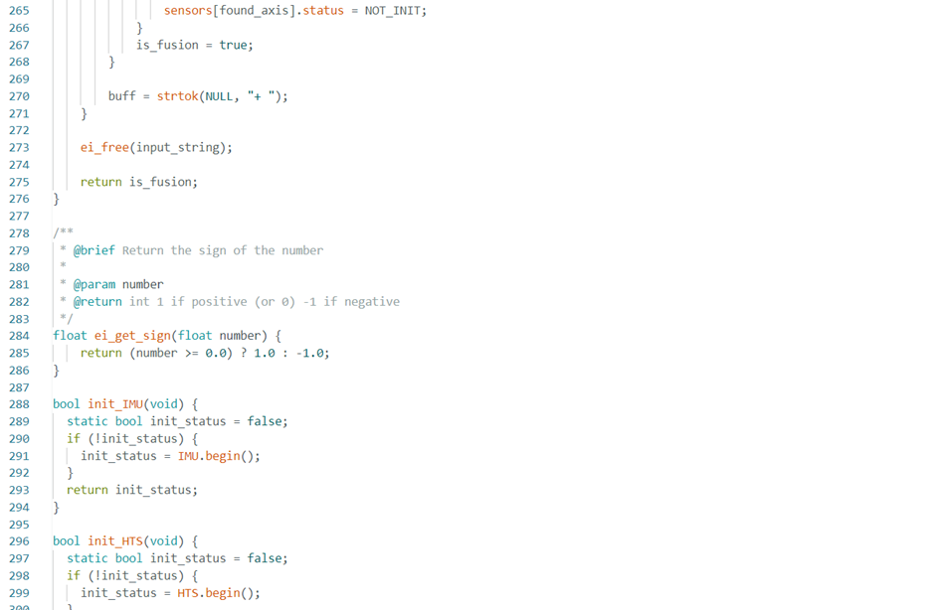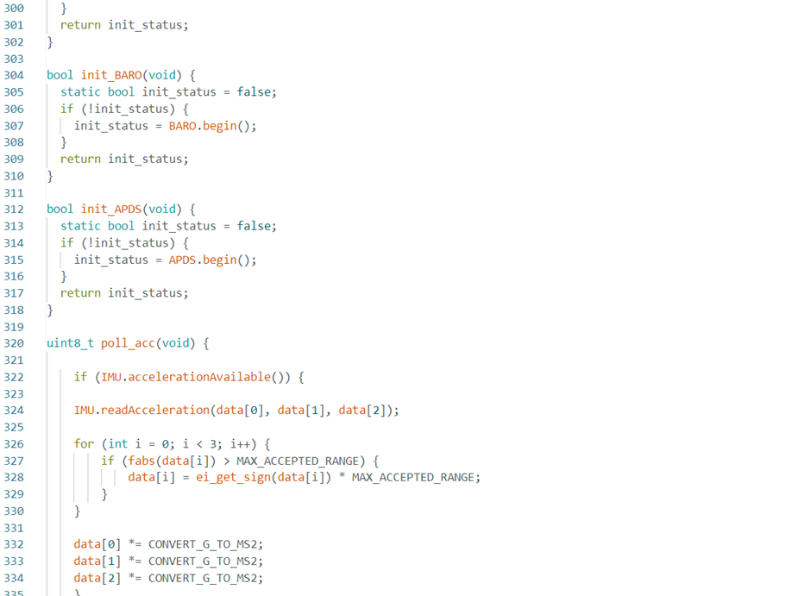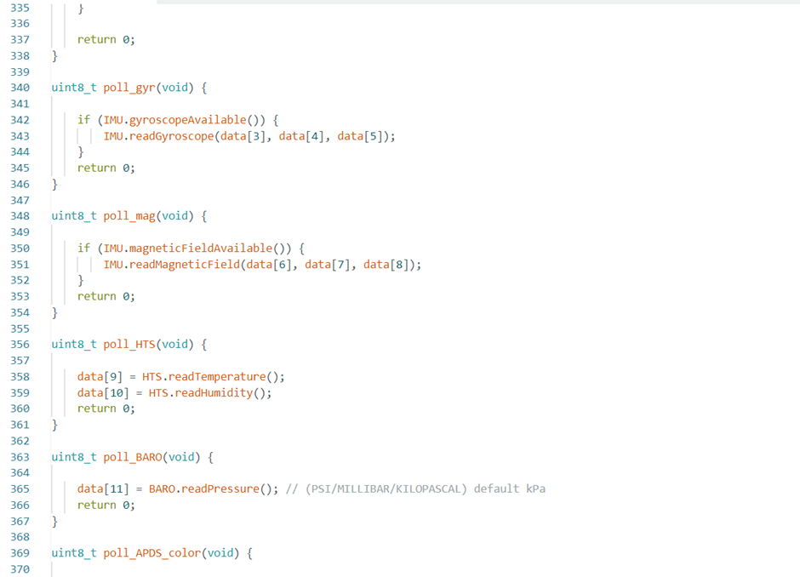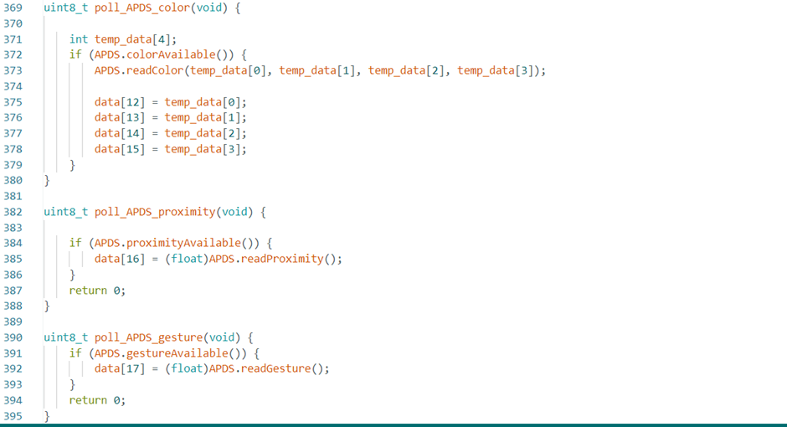

1. Arduino Terminal - Result

Starting Nano BLE Sense Classification...

Sensor data collected.

Running inference...

Predicted Class: White

Confidence: 86.3%

Raw Output: - Red: 10.2% - White: 86.3% - Black: 3.5%

Waiting for next sensor input...

Predicted Class: Red

Confidence: 92.8%

Raw Output: - Red: 92.8% - White: 5.1% - Black: 2.1%

Waiting for next sensor input...